MS Office Excel (Project 5A)
Hey everyone – welcome back! In my next tutorial, I navigated within a worksheet, inserted a hyperlink in a worksheet, and applied and modified themes, styles, lines, and borders to upgrade the format of my worksheets. I used Excel’s advanced table features and database capabilities to organize data in a useful manner. I also used advanced sorting, sorting on multiple columns, and custom filtering to compare subsets of data. Additionally, I limited data to display records that meet one or more specific conditions, add subtotals, and outline data.

Laurel College is in Pennsylvania. The college offers the area a wide range of academic and career programs, including associate degrees, certificate programs, and noncredit continuing education courses. Student success is the top priority for the faculty and staff. The college makes positive contributions to the community through cultural and athletic programs and partnerships with businesses and nonprofit organizations. They also provide industry-specific training programs for local businesses through its Economic Development Center. Michael Schaeffler is the Vice President of Instruction. He has a worksheet that lists the class schedule for the Business Office Systems and Computer Information Systems departments. So, I helped him format and navigate the worksheet.

First, I navigated to the “Home” tab, went to the “Editing” group, clicked, “Find & Select”, and chose “Go To Special”. When I selected “Go To Special”, I got a “Go To Special” pop-up window.

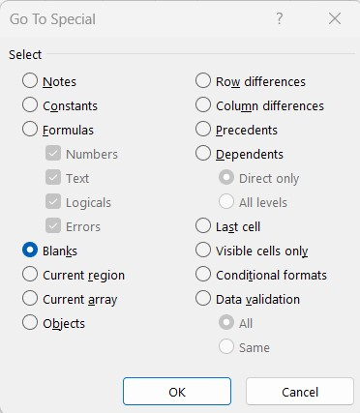

In the first column, I selected “Blanks” and clicked “OK”. The blank cell in the active area of the worksheet is located and selected. The active area is the area of the worksheet that contains data or has contained data and doesn’t include any empty cells that haven’t been used in this worksheet. When I clicked “OK”, cell J33 was already selected for me.

Next, I navigated to the “Home” tab, went to the “Font” Group, and clicked on “Fill Color” to highlight the blank cell in yellow. This missing information needs to be researched before a time can be entered, so the yellow fill color will help me locate this cell later, when the correct time for the class is determined. In cell M50, I navigated to the “Formulas” tab, went to the “Functions Library” group, selected “More Functions”, chose “Statistical”, and selected “COUNTIF”. When I selected “COUNTIF”, I got a “Functions Argument” pop-up window.

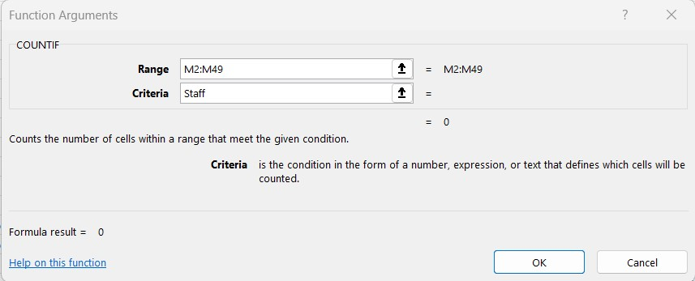

I set the “Range” to “M2:M49” and the “Criteria” to “Staff”. This will count the number of courses that are assigned to Staff and still need an instructor assignment. When I clicked “OK”, my result showed that there are 13 courses that still need an instructor assigned. In cell M49, I replaced “Staff” with “Clark, Martin”. With this replacement, the number of unassigned classes changed from “13” to “12”.

People use worksheets to communicate information both within an organization and outside to the public. A worksheet might be seen by individuals in an email, in a PowerPoint presentation, or in public blogs and publications. So, it’s best to use some creative elements when preparing worksheets. A theme is a predesigned set of colors, fonts, lines, and fill effects that pair well together and can be applied to a workbook. A theme combines two sets of fonts - one for text and one for headings. In the default Office theme, Calibri Light is the font for headings and Calibri is the font for body text. I selected row 1, right clicked, and selected “Insert” to add a new blank row. In cell A1, I typed “Schedule of Classes with Unassigned Sections”. Then, I merged and centered the title across the range from A1 to P1 with the “Title” cell style. On the “Home” tab, I went to the “Styles” group, clicked “Format as Table”, and selected “New Table Style”. When I selected “New Table Style”, I got a “New Table Style” pop-up window.
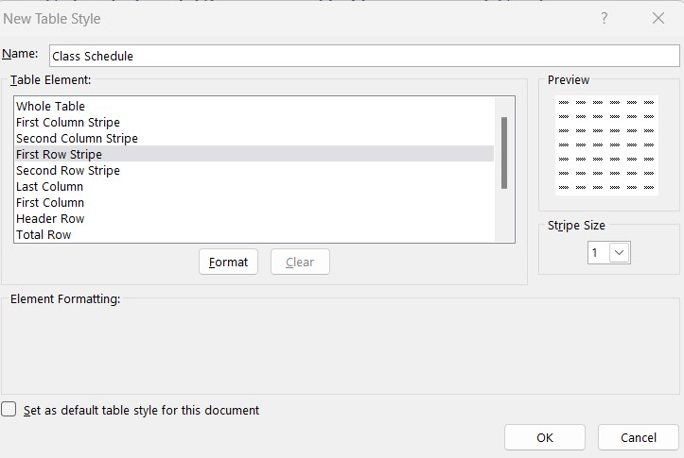

In the “New Table Style” pop-up window, I set the “Name” to “Class Schedule” and the “Table Element” to “First Row Stripe”. Next, I clicked on “Format” and got a “Format Cells” pop-up window.

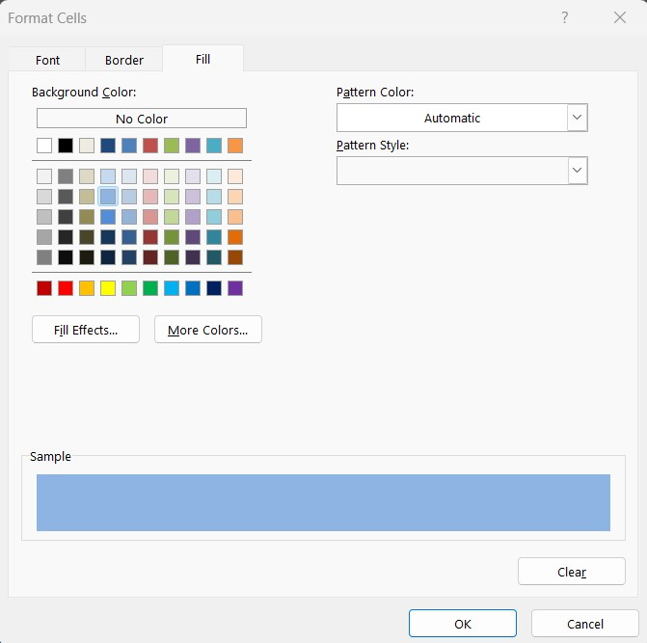

In the “Format Cells” pop-up window, I went to the “Fill” tab and selected the second color in the fourth column of colors. Next, I selected the range from A2:P50, navigated to the “Home” tab, went to the “Styles” group, chose “Format as Table” and chose “Class Schedule”.

So, this is how I used advanced sorting, sorting on multiple columns, and custom filtering to compare subsets of data. Hope this tutorial was helpful and I’ll see you in the next one!

